1. Machine name also uname -n
2. Kernel name, version and release also uname -srv
3. Version of uname command
4. 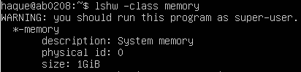System memory amount (GiB)
5. 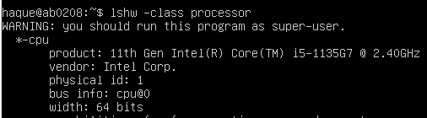Processor
6. 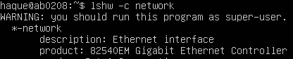Display adapter: lshw -class display
7. Distribution release and description also lsb_release -rd
8. Codename of the distribution